Lab-4
ID : AF05054428
NAME : Vignesh S
Batch code : ALP33393
Module : Data Visualization

TASK 3:
*Index + Match Function
To Find Product Price using list of Kgs
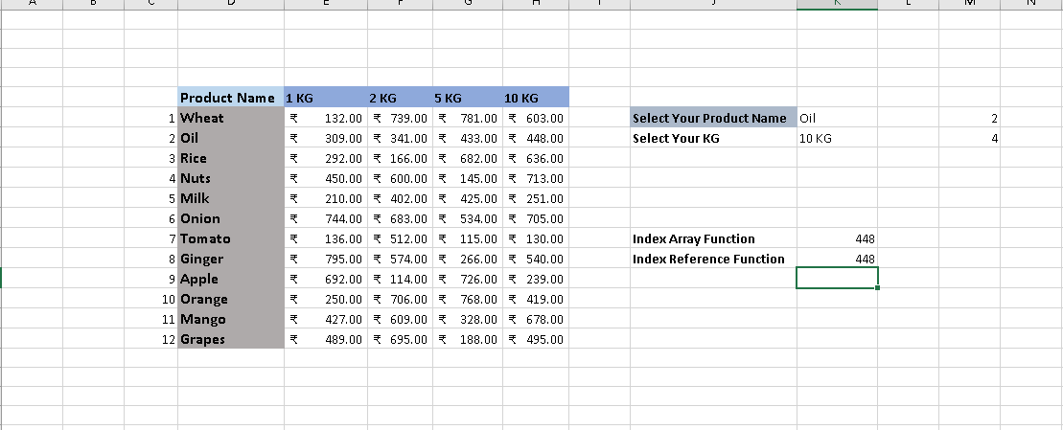
Formula :
=MATCH(K7,E5:H5,0) To find row_num
=MATCH(K7,E5:H5,0) To find col_num
=INDEX(H6:H17,MATCH(K6,D6:D17,0)) Index Array Function
=INDEX(E6:H17,M6,M7) Index Reference Function
Explanation :
- This task uses INDEX+MATCH to find the price of a product based on
the selected product name and KG. MATCH finds the correct row and column (KG) returns the price from that position in the table.

